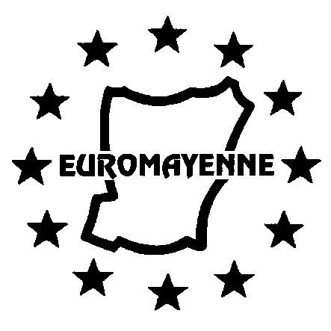

Enrolment Form for EuroMayenne French Lessons
Spring Term 2026

Full details are at www.euromayenne.org follow Language Activities >> French Lessons
These courses are for EuroMayenne members only; EuroMayenne reserves the right to amend or discontinue any course.

Please complete a separate form for each person wishing to enrol.
(IN CAPITAL LETTERS PLEASE)

SURNAME:

First name:
Email address:

I confirm that I have been offered a place on a course, following discussions with the lesson coordinator *

I now wish to enrol and will follow the procedure mentioned below:

Course | First Half | ✓ | Second Half | ✓ | Whole Term | ✓
Beginners, Thursday a.m. | 72 € |  | 72 € |  | 144 €
Intermediate, Tuesday a.m. | 72 € |  | 72 € |  | 144 €
Intermediate +, Tuesday p.m. | 72 € |  | 72 € |  | 144 €
Advanced, Thursday p.m. | 72 € |  | 72 € |  | 144 €
I have already paid my EuroMayenne membership subscription for 2025/26
or I am today sending my membership form for 2025/26 to Simon King**

Please send your completed enrolment form BY EMAIL to the following address frenchlessons@euromayenne.org and transfer payment for your lessons to the EuroMayenne account.

Please visit the ‘Language activities / French Lessons’ webpage on the EuroMayenne website, where you will find instructions for making your payment, together with details of EuroMayenne’s account.

* See webpage for contact details.
** See Simon’s email address on the membership form (available from the webpage).

Please note that course refunds (either full or partial) will only be considered in exceptional
circumstances.

