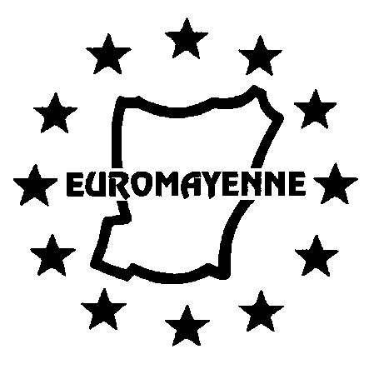

Enrolment Form for EuroMayenne French Lessons

Autumn Term 2025

Full details are at [www.euromayenne.org](http://www.euromayenne.org/) follow Language Activities >> French Lessons

These courses are for EuroMayenne members only; EuroMayenne reserves the right to amend or discontinue any course.

Please complete a separate form for each person wishing to enrol.

(IN CAPITAL LETTERS PLEASE)

|  |
| --- |
| SURNAME : |
| First Name: |
| Address: |
|  |
| Phone numbers - landline: mobile: |
| Email address: |

I confirm that I have been offered a place on a course, following discussions with the lesson coordinator * 🞏

I now wish to enrol and will follow the procedure mentioned below:

|  |  |  |  |  |  |  |
| --- | --- | --- | --- | --- | --- | --- |
| **Course** | **First Half** | **✓** | **Second Half** | **✓** | **Whole Term** | **✓** |
| Beginners, Thursday a.m. | 84 € |  | 84 € |  | 168 € |  |
| Intermediate, Tuesday a.m. | 84 € |  | 72 € |  | 156 € |  |
| Intermediate +, Tuesday p.m. | 84 € |  | 72 € |  | 156 € |  |
| Advanced, Thursday p.m. | 84 € |  | 84 € |  | 168 € |  |

I have already paid my EuroMayenne membership subscription for 2025-2026 🞏

or I am today sending my membership form for 2025-2026 to Simon King** 🞏

**Please send your completed enrolment form BY EMAIL to the following address** [**frenchlessons@euromayenne.org**](mailto:frenchlessons@euromayenne.org) **and transfer payment for your lessons to the EuroMayenne account:**

* **IBAN: FR76 1790 6000 9010 8783 8600 003   BIC: AGRIFRPP879**
* **Please ensure that you include a payment reference of ‘SURNAME, FIRST NAME, COURSE’**
* **Please make your transfer ON or AFTER the 1st SEPTEMBER 2025**

* See webpage for contact details

** See Simon’s email address on the membership form

**Please note that course refunds (either full or partial) will only be considered in exceptional**

**circumstances.**